

2021 Year 12 ViSN Mathematics Specialist Unit 3
Test 3 – Vectors & Vector Calculus
Section One – Calculator Free
Mr Daniel Comtesse  Mandurah Catholic College | Calculator Free:______/20  Calculator Assumed:_____/31
daniel.comtesse@cewa.edu.au | Result: _____/ ______%

Student Name: ___________________________________________

School: ___________________________________________

Time allowed: Section One - 20 minutes

Section Two – 30 minutes

Assessment Date: 2021

Material required/recommended

To be provided by the supervisor
This Question/Answer Paper
SCSA Formula Sheet

To be provided by the candidate
Standard items: pens, pencils, pencil sharpener, eraser, correction fluid/tape, ruler, highlighters

Submission Details
Timed Assessments are to be returned to the ViSN teacher by the ViSN mentor (scan completed assessment and email to teacher above) within 24 hours of assessment date (above).
Instructions to Students

1. ALL questions should be attempted.
2. Write your answers in the spaces provided in this Question/Answer Booklet.
3. SHOW ALL YOUR WORKING CLEARLY. Your working should be sufficient detail to allow your answers to be checked readily and for marks to be awarded for reasoning. Correct answers given without supporting reasoning may not be allocated full marks. Incorrect answers given without supporting reasoning cannot be allocated any marks.
4. If you repeat an answer to any question, ensure that you cancel the answers you do not wish to have marked.
5. It is recommended that you do not use pencil, except in diagrams.

Question 1 [4, 2 = 6 marks]
A system of equations, where $b$ is a real constant, is as follows:

$$x-y+3z=11 \\ x+2y+2z=3 \\ 2x+by+4z=8$$

(a) Solve the system when $b=3$.

(b) Interpret the system of equations geometrically when $b=4$.

Question 2 [2, 4 = 6 marks]
The equation of line $L$ is
$$\frac{x-2}{2}=\frac{y+1}{-3}=\frac{z-1}{6}.$$

(a) Show that the vector equation of the line is $r=\left(\begin{matrix}2 \\ -1 \\ 1\end{matrix}\right)+λ\left(\begin{matrix}2 \\ -3 \\ 6\end{matrix}\right)$

(b) The diameter of sphere $S$ is the segment of line $L$ between $x=2$ and $x=6$. Determine the equation of the sphere.

Question 3 [5, 3 = 8 marks]
Points $A, B, C$ and $D$ have position vectors $\vec{OA}=\left(\begin{matrix}-1 \\ 2 \\ 4\end{matrix}\right), \vec{OB}=\left(\begin{matrix}-3 \\ 1 \\ 7\end{matrix}\right), \vec{OC}=\left(\begin{matrix}3 \\ 4 \\ -2\end{matrix}\right)$ and $\vec{OD}=\left(\begin{matrix}0 \\ 0 \\ 4\end{matrix}\right)$.

Note that $\left|u×v\right|=\left|u\right|\left|v\right|\sin{θ}$, where $θ$ is the angle between $u$ and $v$.

(a) Determine $\left|\vec{AB}×\vec{AC}\right|$ and use the result to explain why $A, B$ and $C$ are collinear.

(b) Determine the Cartesian equation of the plane containing all four points.

End of Section One
Extra working page
Question number: _________



2021 Year 12 ViSN Mathematics Specialist Unit 3
Test 3 – Vectors & Vector Calculus
Section Two – Calculator Assumed
Mr Daniel Comtesse  Mandurah Catholic College | Calculator Assumed:_____/
daniel.comtesse@cewa.edu.au

Student Name: ___________________________________________

School: ___________________________________________

Time allowed: Section One - minutes

Section Two – minutes
Assessment Date: 2021

Material required/recommended

To be provided by the supervisor
This Question/Answer Paper
SCSA Formula Sheet

To be provided by the candidate
Standard items: pens, pencils, pencil sharpener, eraser, correction fluid/tape, ruler, highlighters
Special items: scientific and/or CAS calculator, one A4 (one sided) page of notes.

Submission Details
Timed Assessments are to be returned to the ViSN teacher by the ViSN mentor (scan completed assessment and email to teacher above) within 24 hours of assessment date (above).
Instructions to Students

1. ALL questions should be attempted.
2. Write your answers in the spaces provided in this Question/Answer Booklet.
3. SHOW ALL YOUR WORKING CLEARLY. Your working should be sufficient detail to allow your answers to be checked readily and for marks to be awarded for reasoning. Correct answers given without supporting reasoning may not be allocated full marks. Incorrect answers given without supporting reasoning cannot be allocated any marks.
4. If you repeat an answer to any question, ensure that you cancel the answers you do not wish to have marked.
5. It is recommended that you do not use pencil, except in diagrams.

Question 3 [3, 2 = 5 marks]
Find the Cartesian equation of the following vector functions:
- $r\left(t\right)=\left(1-2\cos\left(t\right)\right)i+3\sin\left(t\right) j$

- $r\left(t\right)=2\sec\left(t\right) i+\tan\left(t\right) j$

Question 4 [3, 3, 2 = 8 marks]
Drone $A$ and drone $B$ move with constant velocities and relative to the origin $O$ have initial positions $(-4, 22, 2)$ and $(5, 15, 3)$ respectively, where distances are in metres.

One second later, the position of $A$ is $(-1, 20, 3)$ and the position of $B$ is $(1, 14, 8)$.
(a) Determine a position vector relative to the origin for each drone after $t$ seconds.

(b) Determine an expression for the distance between the two drones at any time $t, t≥0$.

(c) Determine the minimum distance between the drones.

Question 5 [2, 2, 2 = 6 marks]
The path of a particle with position vector $r\left(t\right)=\begin{matrix}15t \\ \overline{1+t^{3}}\end{matrix}i+\begin{matrix}15t^{2} \\ \overline{1+t^{3}}\end{matrix}j$ metres is shown below, where $t$ is the time in seconds and $t≥0$.

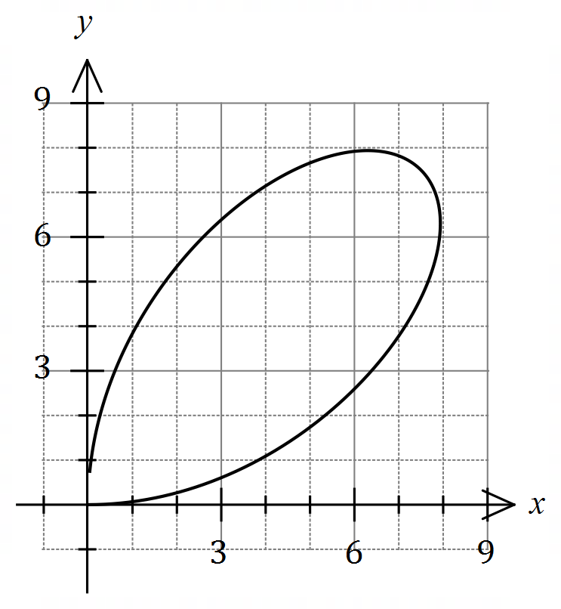

(a) Determine the initial velocity of the particle.

(b) Determine the velocity of the particle at the instant, $t>0$, when it is moving parallel to the
$x$-axis.

- Explain whether the particle will return to its initial position.

Question 6 [3 marks]

Plane $Π$ has equation $r=\left(\begin{matrix}3 \\ -2 \\ 4\end{matrix}\right)+μ\left(\begin{matrix}2 \\ 1 \\ -1\end{matrix}\right)+λ\left(\begin{matrix}1 \\ -1 \\ 2\end{matrix}\right)$. Determine the Cartesian equation of $Π$.

Question 7 [2, 3, 4 = 9 marks]
The position vectors of particles $A$ and $B$ (in centimetres) at time $t$ seconds, $t≥0$, are

$r_{A}=7i+15j+t(0.5i-2j)$ and $r_{B}=5i+2j+t\left(\left(t-6\right)i-j\right)$.

(a) Show that $A$ is moving with constant speed and determine this speed.

(b) Determine the Cartesian path of $B$.

(c) Determine the position vector of the point where the paths of the particles cross and state whether a collision occurs.

End of Assessment
Extra working page
Question number: _________

